SwaggerHub

🌟 Definition
# Source: AI Source: Provided by: [Data Path: Persons Table -> ID Column: 1, Name_En Column: Motasem Essam] -> From: [ChatGPT] on [6/2/2026]
SwaggerHub is an API Design & Collaboration Platform used to design, document, standardize, and manage APIs using the OpenAPI Specification (formerly Swagger Specification).
It focuses on the API-first development approach, where the API is designed before it is implemented.
Official website:
SwaggerHub

🎯 Purpose
# Source: AI Source: Provided by: [Data Path: Persons Table -> ID Column: 1, Name_En Column: Motasem Essam] -> From: [ChatGPT] on [6/2/2026]
SwaggerHub helps teams:
- Design APIs
- Document APIs
- Standardize API definitions
- Collaborate on API development
- Generate API specifications
- Manage API versions
- Govern API standards across organizations

🔢 Main Features of SwaggerHub

1. 🏗️ API Design
# Source: AI Source: Provided by: [Data Path: Persons Table -> ID Column: 1, Name_En Column: Motasem Essam] -> From: [ChatGPT] on [6/2/2026]
🌟 Purpose
Design APIs before writing code.
Example OpenAPI definition:
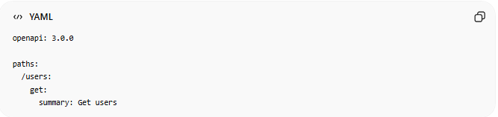
openapi: 3.0.0
paths:
/users:
get:
summary: Get users

2. 📚 API Documentation
# Source: AI Source: Provided by: [Data Path: Persons Table -> ID Column: 1, Name_En Column: Motasem Essam] -> From: [ChatGPT] on [6/2/2026]
🌟 Purpose
Automatically generate professional API documentation.
Documentation includes:
- Endpoints
- Parameters
- Request examples
- Response examples
- Authentication details

3. 📜 OpenAPI Specification Support
# Source: AI Source: Provided by: [Data Path: Persons Table -> ID Column: 1, Name_En Column: Motasem Essam] -> From: [ChatGPT] on [6/2/2026]
🌟 Purpose
Create APIs using the OpenAPI standard.
Example:
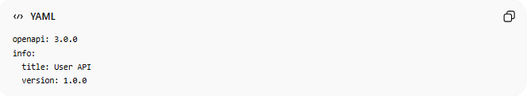
openapi: 3.0.0
info:
title: User API
version: 1.0.0

4. 🤝 Team Collaboration
# Source: AI Source: Provided by: [Data Path: Persons Table -> ID Column: 1, Name_En Column: Motasem Essam] -> From: [ChatGPT] on [6/2/2026]
🌟 Purpose
Allow teams to work on API definitions together.
Features:
- Shared projects
- Comments
- Reviews
- Approval workflows

5. 🔄 API Versioning
# Source: AI Source: Provided by: [Data Path: Persons Table -> ID Column: 1, Name_En Column: Motasem Essam] -> From: [ChatGPT] on [6/2/2026]
🌟 Purpose
Manage multiple API versions.
Example:
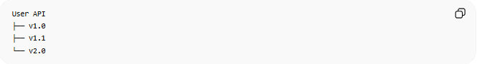
User API
├── v1.0
├── v1.1
└── v2.0

6. 📏 API Governance
# Source: AI Source: Provided by: [Data Path: Persons Table -> ID Column: 1, Name_En Column: Motasem Essam] -> From: [ChatGPT] on [6/2/2026]
🌟 Purpose
Ensure APIs follow company standards.
Examples:
- Naming conventions
- Security rules
- Documentation requirements

7. 🔐 Security Definition Management
# Source: AI Source: Provided by: [Data Path: Persons Table -> ID Column: 1, Name_En Column: Motasem Essam] -> From: [ChatGPT] on [6/2/2026]
🌟 Purpose
Define API security requirements.
Examples:
- API Keys
- OAuth 2.0
- JWT
- Bearer Tokens

8. ⚙️ Code Generation
# Source: AI Source: Provided by: [Data Path: Persons Table -> ID Column: 1, Name_En Column: Motasem Essam] -> From: [ChatGPT] on [6/2/2026]
🌟 Purpose
Generate code from API definitions.
Possible outputs:
- Server stubs
- Client SDKs
- Documentation
Supported languages include:
- Java
- PHP
- Python
- JavaScript
- C#
- Go

9. 🧪 Mock APIs
# Source: AI Source: Provided by: [Data Path: Persons Table -> ID Column: 1, Name_En Column: Motasem Essam] -> From: [ChatGPT] on [6/2/2026]
🌟 Purpose
Create mock endpoints before backend development.
Example response:
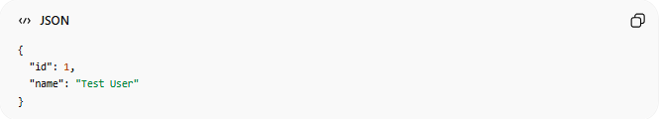
{
"id": 1,
"name": "Test User"
}

10. 🔗 Integration with Development Tools
# Source: AI Source: Provided by: [Data Path: Persons Table -> ID Column: 1, Name_En Column: Motasem Essam] -> From: [ChatGPT] on [6/2/2026]
🌟 Purpose
Connect with:
- GitHub
- GitLab
- Bitbucket
- CI/CD systems

📄 Example OpenAPI Definition
# Source: AI Source: Provided by: [Data Path: Persons Table -> ID Column: 1, Name_En Column: Motasem Essam] -> From: [ChatGPT] on [6/2/2026]
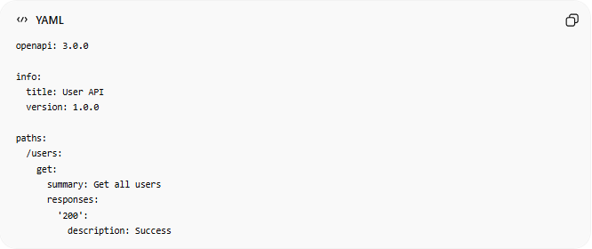
openapi: 3.0.0
info:
title: User API
version: 1.0.0
paths:
/users:
get:
summary: Get all users
responses:
'200':
description: Success

🔗 How SwaggerHub Works
# Source: AI Source: Provided by: [Data Path: Persons Table -> ID Column: 1, Name_En Column: Motasem Essam] -> From: [ChatGPT] on [6/2/2026]
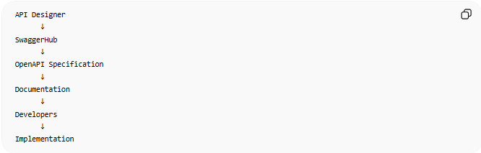
API Designer
↓
SwaggerHub
↓
OpenAPI Specification
↓
Documentation
↓
Developers
↓
Implementation

⚖️ SwaggerHub vs Postman
# Source: AI Source: Provided by: [Data Path: Persons Table -> ID Column: 1, Name_En Column: Motasem Essam] -> From: [ChatGPT] on [6/2/2026]
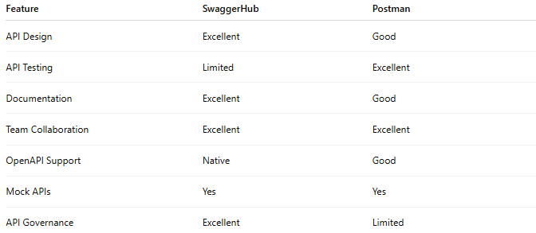
Feature | SwaggerHub | Postman
API Design | Excellent | Good
API Testing | Limited | Excellent
Documentation | Excellent | Good
Team Collaboration | Excellent | Excellent
OpenAPI Support | Native | Good
Mock APIs | Yes | Yes
API Governance | Excellent | Limited

⚖️ SwaggerHub vs Insomnia
# Source: AI Source: Provided by: [Data Path: Persons Table -> ID Column: 1, Name_En Column: Motasem Essam] -> From: [ChatGPT] on [6/2/2026]
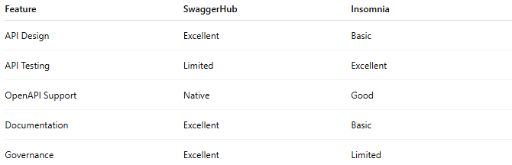
Feature | SwaggerHub | Insomnia
API Design | Excellent | Basic
API Testing | Limited | Excellent
OpenAPI Support | Native | Good
Documentation | Excellent | Basic
Governance | Excellent | Limited

🧠 Simple Analogy
# Source: AI Source: Provided by: [Data Path: Persons Table -> ID Column: 1, Name_En Column: Motasem Essam] -> From: [ChatGPT] on [6/2/2026]
Think of:
- cURL = making API calls manually 📞
- Insomnia = lightweight API testing workstation 🛠️
- Postman = complete API development platform 🖥️
- SwaggerHub = architectural blueprint and documentation system 🏗️📘
SwaggerHub focuses more on designing and defining APIs, while Postman and Insomnia focus more on testing and interacting with APIs.

🧭 Summary
# Source: AI Source: Provided by: [Data Path: Persons Table -> ID Column: 1, Name_En Column: Motasem Essam] -> From: [ChatGPT] on [6/2/2026]
SwaggerHub is an API Design & Collaboration Platform that helps teams design, document, standardize, version, and govern APIs using the OpenAPI Specification. It is one of the leading tools for API-first development and enterprise API management.

